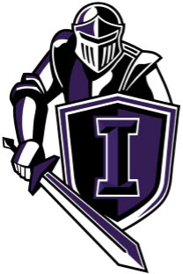
2020 Game Day Program Spirit Ad
Knights Spirit Ads are for EVERYONE!
The Knights Game Day Program is a great way to remember the 2020 season!

Ad Sizes Available:
¼ Page… $15.00
½ Page… $25.00
Full Page… $50.00

Ad Requirements
High-resolution pictures MUST be submitted in Microsoft Picture or other graphic programs; JPEG, PDF and PSD documents. Please email them to Holly Cannatelli at hcannatel@gmail.com. Please also send any message you’d like printed in the ad along with the picture.

Deadline & Payment
Ads are due no later than October 15th. Go onto our website at knightsdigitclub.com and click on the tab Store at the top. You’ll find the option for the Game Day Program Spirit Ad here.

